**Test analysis for Ui and Api testing**

**General review:**

* Project Name: Evershop
* Prepared By: Arifa Yasmin
* Date: 19/9/2024

**Objectives**

1.Ensure a smooth user experience on the site.

2.verify both functionalities from Api and Ui

**Test Scope**

UI Testing

* Home page layout
* Product details
* Shopping cart
* Checkout process

API Testing

Product API (GET Request)

Cart API(GET Request )

**Test Strategies:**

UI Testing

Types of Testing

* Functional Testing
* Usability Testing

**Api Testing**

Types of Testing

* Functional Testing

Tools: Postman

Test Cases

UI Test Cases

* Home Page: Check if featured products display correctly.
* Shopping Cart: Ensure items can be added
* Checkout: Validate order summery and payment amount.

API Test Cases:

Product API: Ensure correct product data is returned.

Cart API: Verify items can be added successfully

**Bug analysis:**

<https://demo.evershop.io/assets/frontStore/cart/client/a3f0705825866defa866.css>

for this Api URL, mismatch status code from Api to Ui

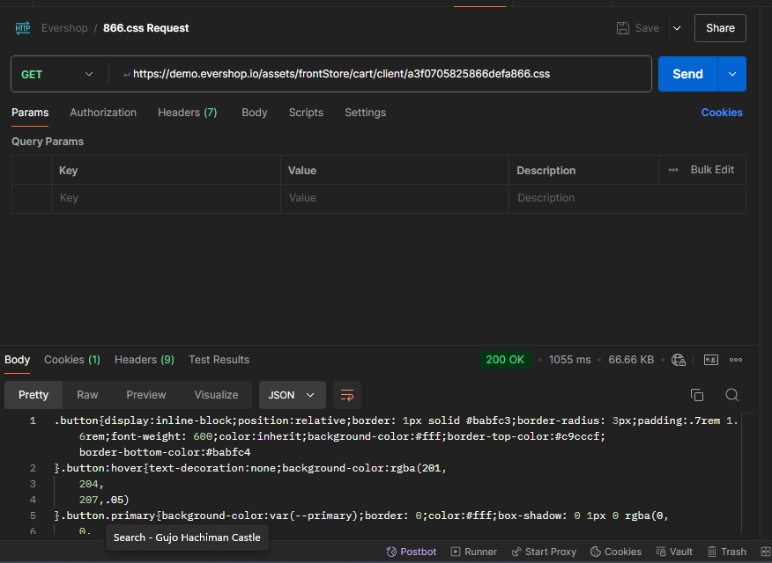

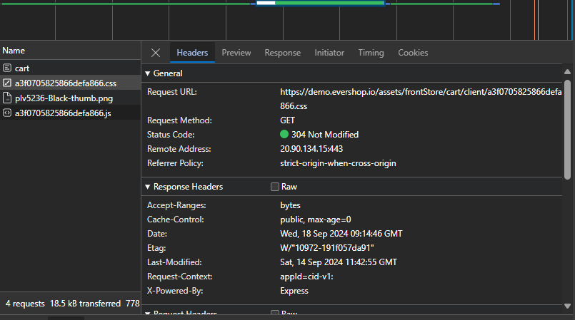

https://demo.evershop.io/assets/frontStore/cart/client/a3f0705825866defa866.js

for this Api URL, mismatch status code from Api to Ui

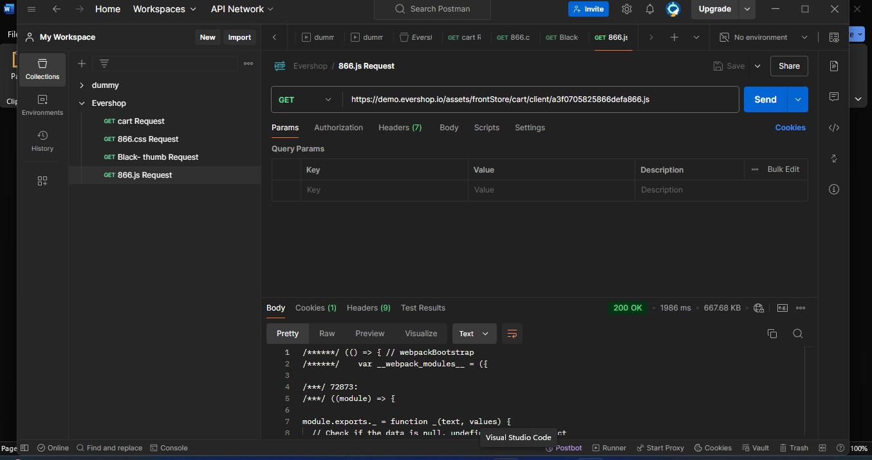



**Suggestion:** make sure status code should be same for both Api and Ui.

**Conclusion:**

This document outlines the testing approach for the Evershop site, focusing on delivering a user-friendly experience and ensuring the backend functions properly.